Illustrator in Residency

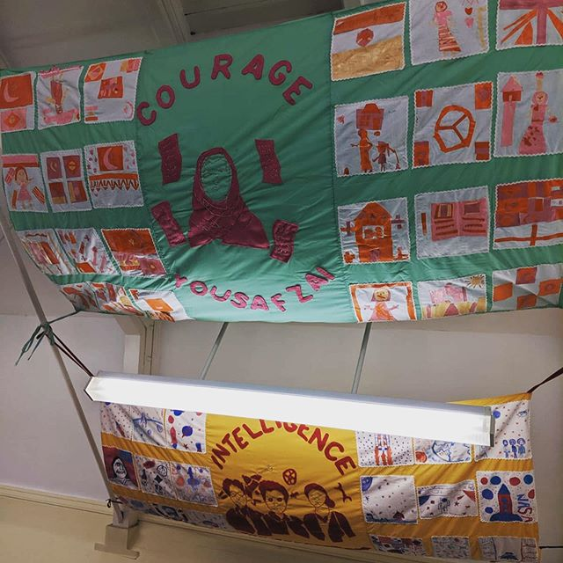
For my illustration residency I was asked to create 4, 2.5m x 1m final pieces. that would incorporate work I was been teaching the children as well as a panel of my own.

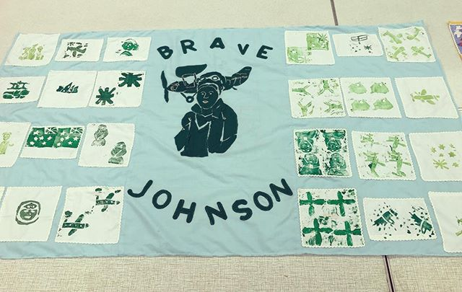
The theme of this project was pioneering woman. These women were: Amy Johnson (year 6), Katherine Johnson, Mary Jackson, Dorothy Vaughan (year 5), Malala Yousafzai (year 4) and Matilde (year 3). Each woman was choose by the school which meant i had to first do research into them to ensure the children had some information on them before beginning the art part of the project.
I also decided that each year should have a different colour scheme, and media to work with. But would all cohesively work together too.

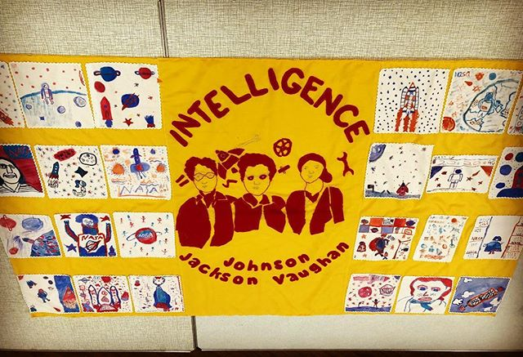
For Years 6 I taught them how to use printing techniques using relief printing with foam. So something they would be able to replicate again in the future which also taught them about the use of negative space.
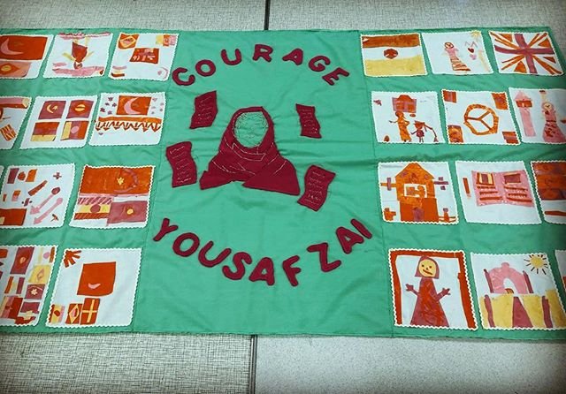
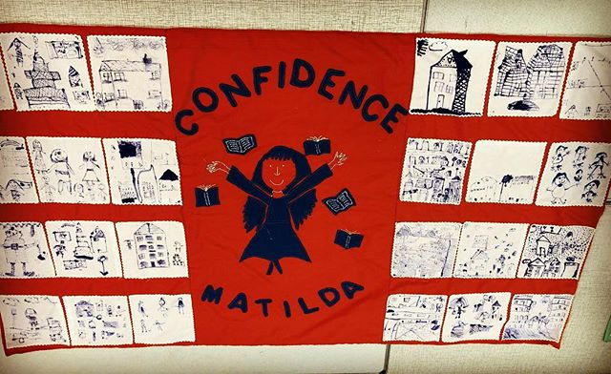
For Years 5 I taught them about watercolours and the different effects you can not only produce on paper but also fabric. Which they will then be able to continue to learn throughout their time in school.

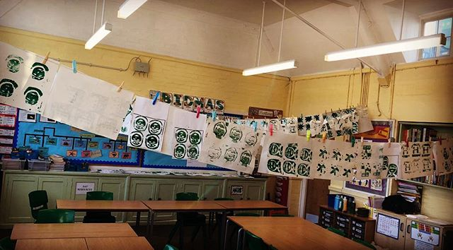
For Years 4 I taught them how to produce collage using a limited colour palette. This was something they had normally not had to do even if they had used collage before as they were used to using the correct colours. Whereas I challenged them to stick to the colour theme I had chosen.

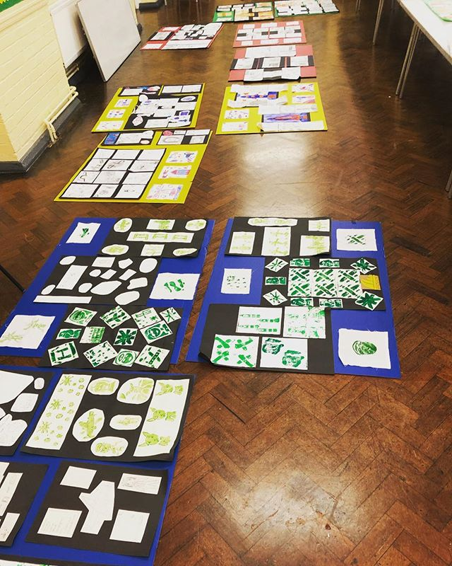
For Year 3 I used the method of stick and ink, which is where you use a kebab stick as a pen with it dripped into ink to draw. this was a bigger challenge then originally thought as they often spilled the ink or used to much creating blotching. I encouraged them to embrace these mistakes and use them to there advantage. for instance one child them made it into a swimming pool.

These lessons were done over 4 years (ages 7-10) with for classes over each year so in total 480 children these skills in 10 weeks.
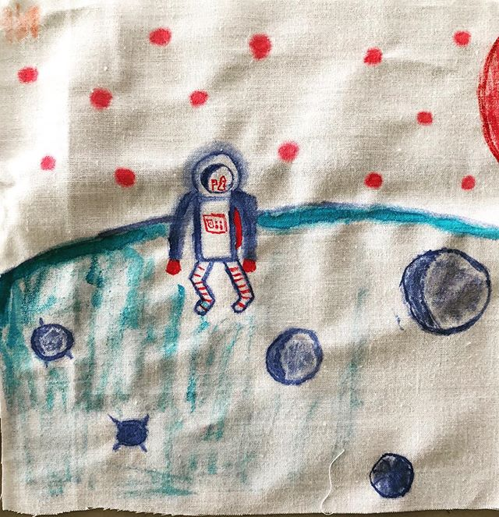
These 10 weeks also included me producing the middle panel, which is a mixture of embroidery and sewing.
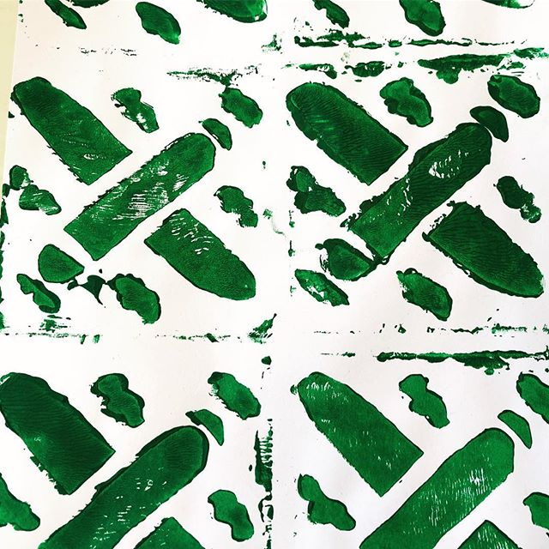
Once the work was produced we had an end of project exhibition, which I helped to display that included the work that had not been included in the final piece as well as other development work.

These pieces are now a permanent display in the school library.

